Concur
Reference Guide
Approval
03/22

Table of Contents
Approval 2
Approving a Travel Request 2
Sending Back a Request 4
Adding an Additional Reviewer/Approver Step for a Request 5
Reviewing and Approving an Expense Report 6
Sending Back an Expense Report 7
Adding an Additional Reviewer/Approver Step for an Expense Report 8
Delegating Approver Duties 9
Acting as a Delegate Approver 11

Approval

Approving a Travel Request
The approver will see requests awaiting approval under Required Approvals on the Concur home page.
On the home page, in the Required Approvals section of My Tasks, click on the Required Approvals tile of the blue arrow to the right.
OR
On the home page, in the Quick Task Bar, click the Required Approvals tile.

The Reports Pending your Approval page lists the awaiting reports. Select the report you want to open.
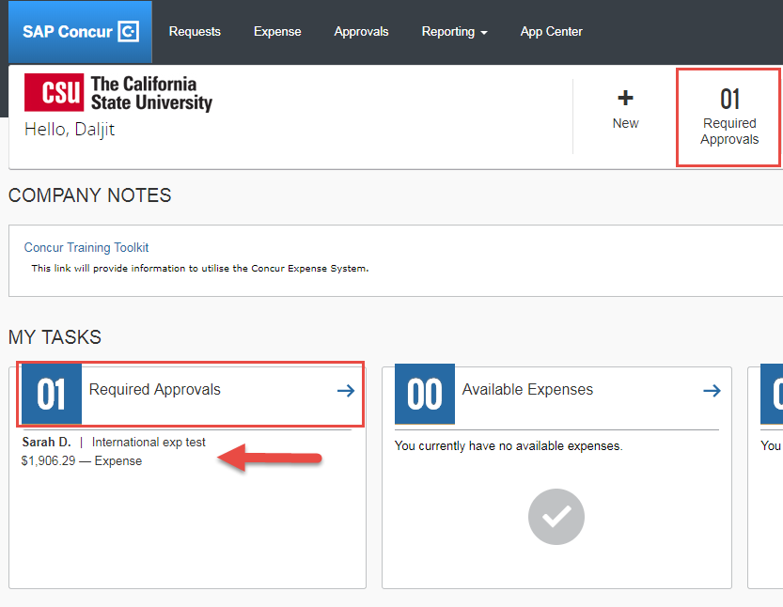
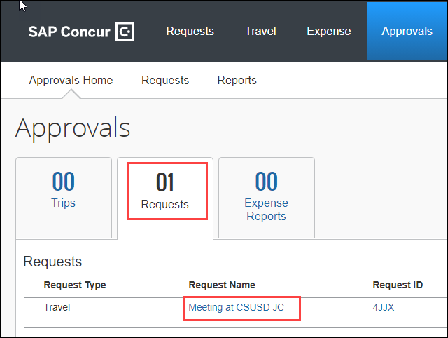

- Select the Request you wish to approve by clicking the Request Name.
- Review the Request Header, Expected Expenses, and any Alerts. Things to consider:
  - Review destination and see if banned state or alerts for high hazard destinations are noted.
  - Take note of any personal days and consider that estimated costs are prorated accordingly (i.e. daily meal allowances, incidentals, etc.).
  - Review attachments to obtain further information about the purpose of trip.
  - Review all expenses for reasonableness and completeness.
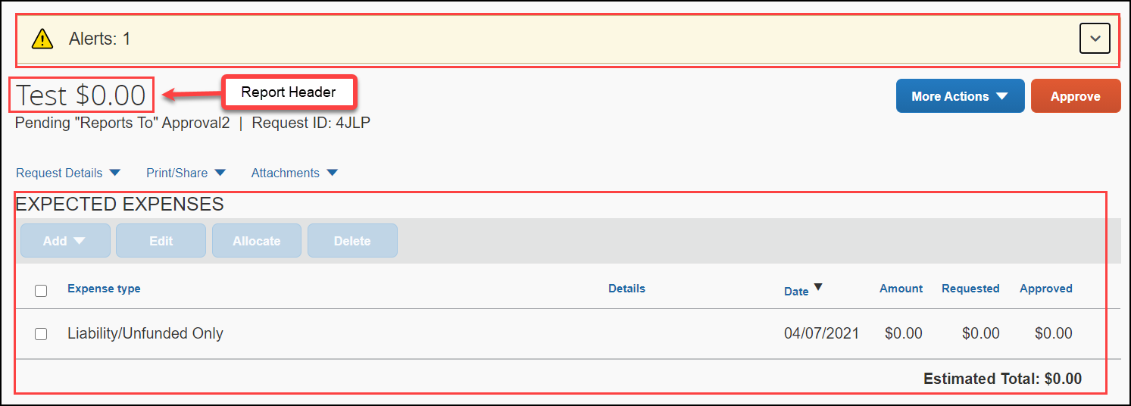
- There are three approval options.
  - Approve – Approve the Request.
Under More Actions:
  - Edit Approval Flow – Allows you to add additional approvals into the workflow. Click + Add Step to enter a User-Added Approver box, type in the last name of the approver and select from the dropdown box. You can only select users who are already designated as approvers in the system.
  - Send Back to Employee – Return the Request to the traveler. Use the Comment field in the Send Back Report window to explain the reason the report is being returned, then click OK.
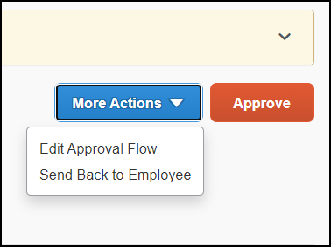
Once Travel Requests have been acted on by the approver, notification regarding the status will be sent to the traveler (and delegate if opted into notifications) and the status will be noted on the traveler’s Manage Requests page.
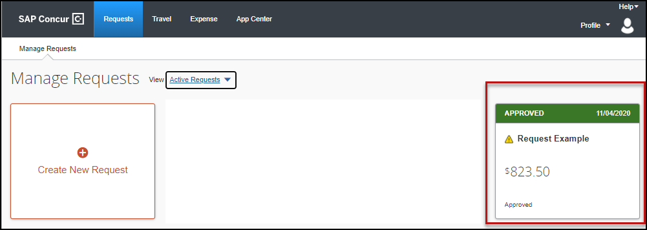

Sending Back a Request
During your review, you may choose to return the request to the employee for correction.
To return a report:
- Click More Actions, then click Send Back to Employee.
- Enter a Comment for the employee explaining why you are returning the request
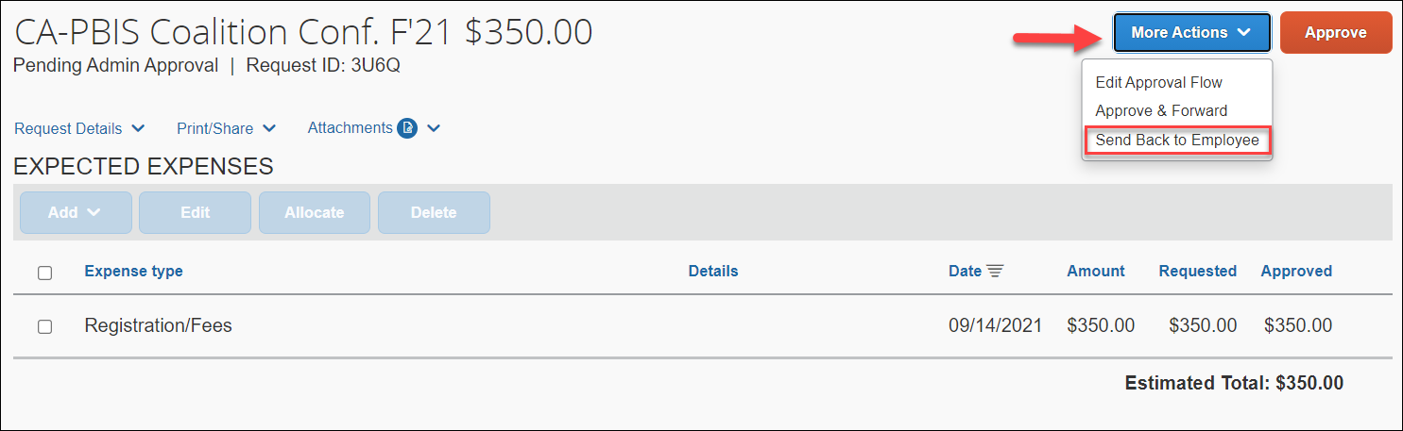
- Click OK.

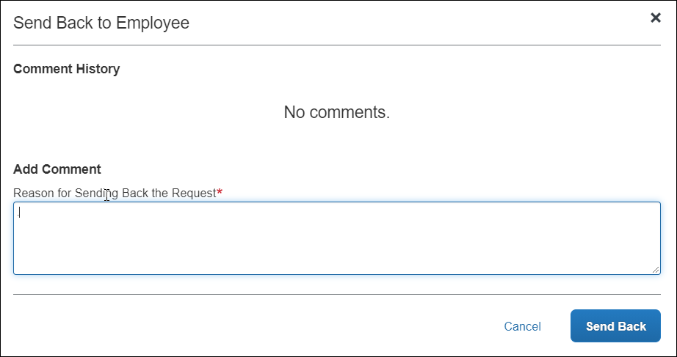

Adding an Additional Reviewer/Approver Step for a Request
You will have the ability to send the report to another approver. To approve and forward a report:
- At the top right of the screen, click More Actions, then click Approve & Forward.
- Enter the User-Added Approver.
- To add more than one approver, click Add Step. This will add another User-Added Approver to the workflow.
- Click Save.
- Click Approve to approve the Request and send to the next approver.
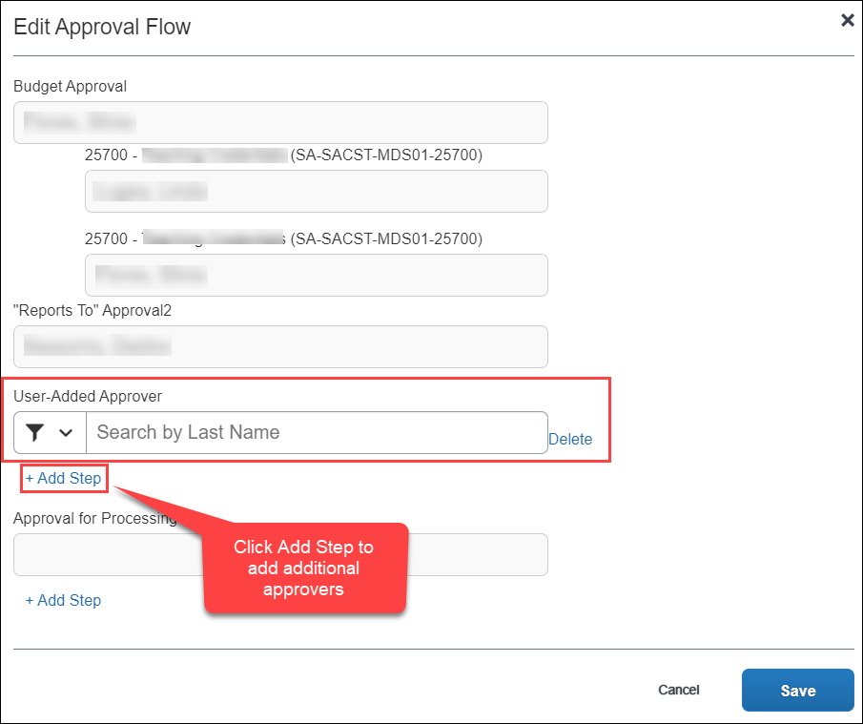

- For Budget Approvers- Click More Actions and select Edit Approval Flow before approving. You will have the ability to add an additional approver to the workflow. See screenshots below.

- If you want to add an additional Approver after the Budget Approval, you can do so by clicking on the +Add Step under the “Budget Approver” line. The +Add Step under “Reports To”Approval2 will enter an additional approver after the “Report To” Approver.
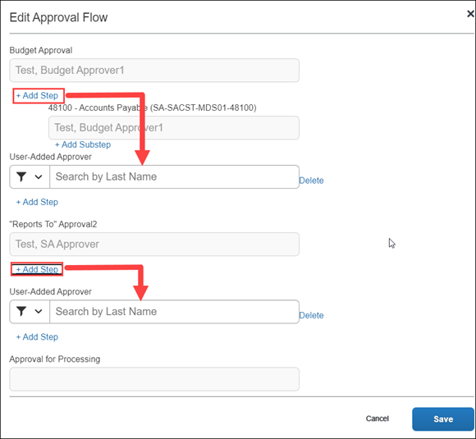

Reviewing and Approving an Expense Report
Reviewing an Expense Report
On the home page, in the Required Approvals section of My Tasks, click on the Required Approvals tile of the blue arrow to the right.
OR
On the home page, in the Quick Task Bar, click the Required Approvals tile.

The Reports Pending your Approval page lists the awaiting reports. Select the report you want to open

- Review the report details. Things to consider:
  - Review dates and locations of expenses compared to the original request.
  - Take note of any personal days on the request and whether expenses were claimed on those dates.
  - Look at any Exceptions.
  - Compare the total amount being claimed for reimbursement with what was requested.
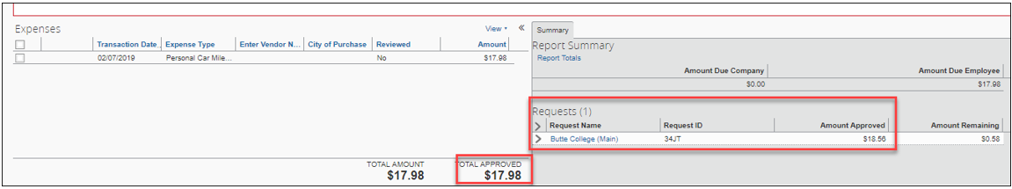
  - Review all expenses for reasonableness and completeness.

Approving an Expense Report
If you are satisfied with the Expense Report, click Approve in the top right corner of the screen.

Sending Back an Expense Report
During your review, you may choose to return the entire expense report to the employee for correction.
To return a report:
- Click Send Back to User. The Send Back Report window appears.
- Enter a Comment for the employee explaining why you are returning the report.
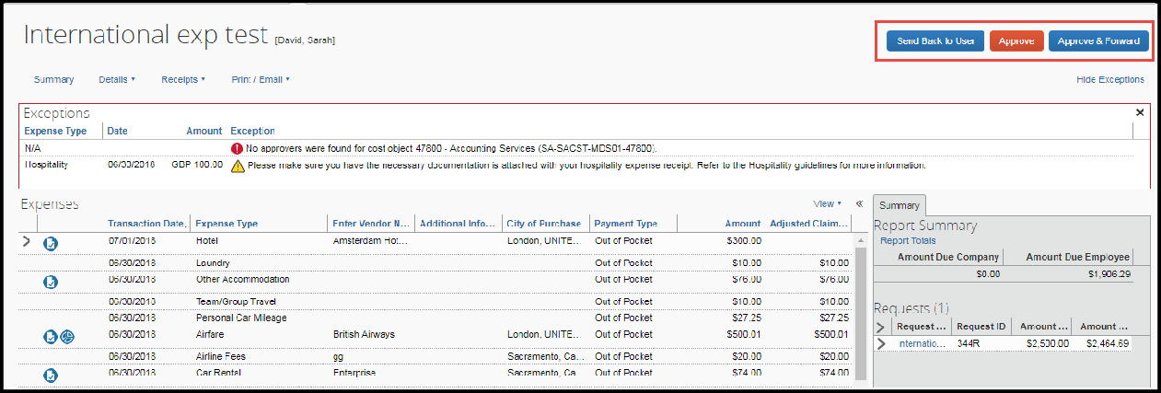
- Click OK.
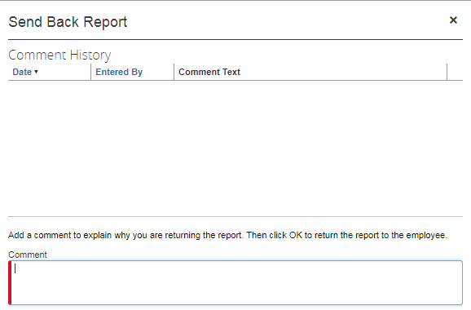

Adding an Additional Reviewer/Approver Step for an Expense Report
You will have the ability to send the report to another approver. To approve and forward a report:
- Click the Approve & Forward button in the top right of the screen.
- Enter the User-Added Approver, and add a comment, as needed.
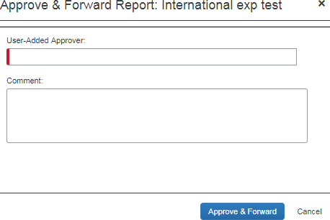
- Click Approve & Forward to approve the Expense Report and send to the next approver.

- For Budget Approvers- Click Details and select Approval Flow before approving. You will have the ability to add an additional approver to the workflow. See screenshots below.
- If you want to add an additional User-Added Approver after the Budget Approval, you can do so by clicking on the addition sign next to the “Report To” Approver2 line. The right addition sign next to the Approval for Processing line will enter an additional approver after the “Report To” Approver.

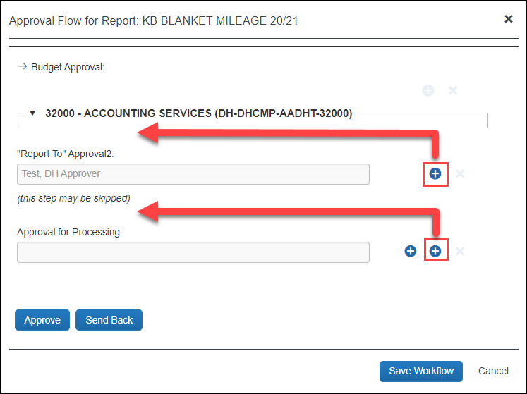

Delegating Approver Duties
In the case of an absence an approver can delegate the approval step to another person for a temporary window of time.

To add a delegate:
- Click Profile > Profile Settings, on the left-hand side of the page under the Request Settings header click Request Delegates or under Profile Options select Expense Delegates. Either area will auto update the other.
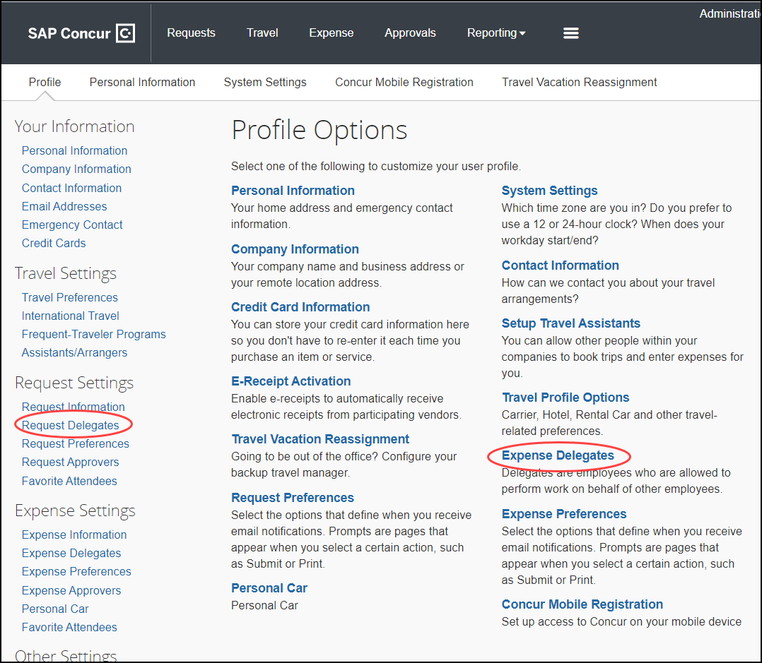

- On the Delegates page, click Add. The search area appears.
- Type at least the first three letters of the employee's last name to search for the person you wish to add as a Delegate and click Add. You may also search by first name or email address.
- Check the boxes that correspond with the permissions you are granting to the delegate. In the example below, if you wanted to delegate the approval function only you would check “can approve temporary” add the dates of temporary approval authority and check the “receives approval emails” so that they are also notified as submissions occur. Note: Make sure “receive approval emails” is checked or delegate will not receive notification of pending approvals.

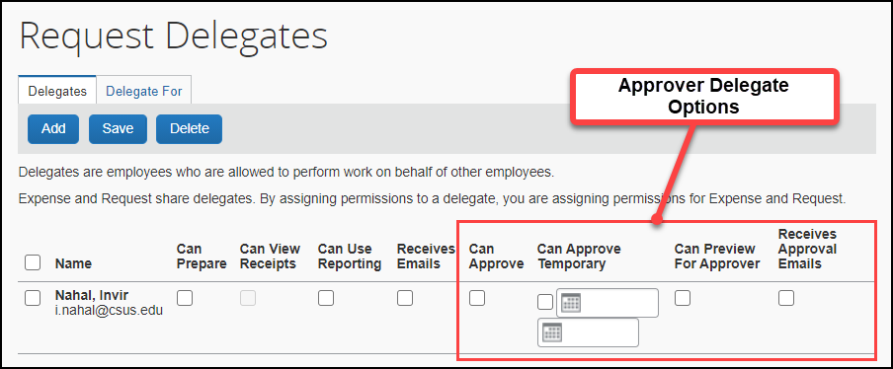

Option | Description
*Can Prepare | If selected, the delegate can create expense reports and requests on your behalf.
*Can View Receipts | If selected, the delegate can view receipt images on your behalf.
*Receives Emails | If selected, the delegate receives a copy of each Expense related email that you receive, except for approval emails.
(*) Can Approve | If selected, the delegate can approve expense reports, and requests on your behalf, without date constraints.
(*) Can Approve Temporary | If selected, the delegate can approve expense reports and requests on your behalf but only for the specified period. If you select this option, you must also select the beginning and ending date.
Can Preview for Approver | If selected, the delegate can preview requests and expense reports on behalf of another employee. This delegate cannot approve the request/expense report. Note: Allows delegate to review requests/reports prior to you approving.
Receives Approval Emails | If selected, the delegate receives a copy of each Expense approval-related email that you receive.

* These options are regarding your own travel requests and expense reports. These are not used for delegate approval options.
(*) The option to delegate approver rights will only be available for Approvers in the system. The approver’s rights can only be delegated to another user who also has approval rights in the system. This function can be used for times when an approver is unavailable and approval tasks will be covered by another person in their absence (i.e. Dean unavailable and approvals would be routed to Provost).
- Click Save.
- To delete a delegate click the checkbox to select the person, click Delete, and confirm deletion.

Acting as a Delegate Approver
If you have been assigned to work as a delegate, your delegator will define which tasks you can complete, such as previewer, temporary approver, or always approver roles.
To work as a delegate:
- Click Profile.
- Under Acting as other user, enter the delegator’s name or select the appropriate from the drop down. Note: If you are unable to pull up the name, then you are not set up to delegate for the delegator. You will need to reach out to the individual to have them set you up.
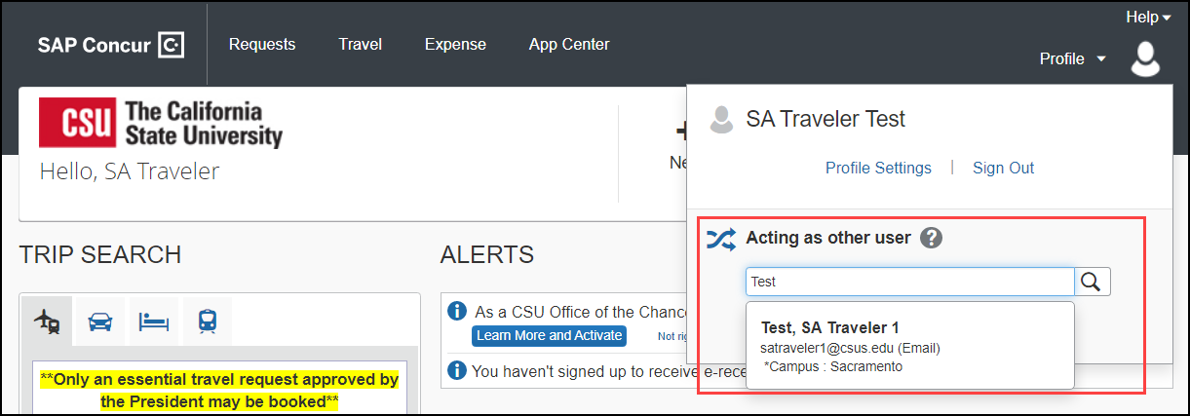
- Click Start Session.
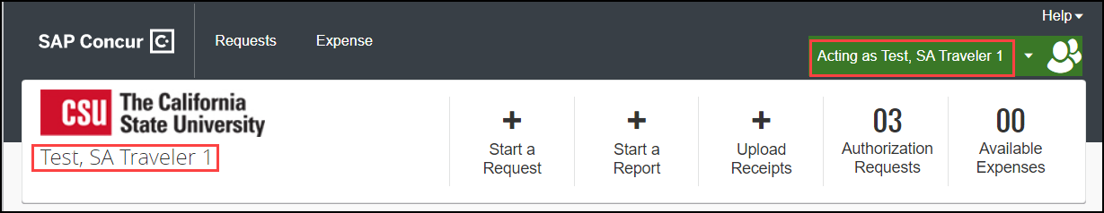
- Notice the Profile menu now displays Acting as and shows the name of the employee you are acting on behalf.
- You are now officially working on behalf of that person. Complete the normal processes for approving as shown above.
- For Previewers- Once the Request or Expense report is reviewed, the Delegate can use the “Notify Approver” button to let the approver know the Request or Expense report is ready to Approve. The Approver must certify and approve themselves.
To return to your own tasks, click the down arrow next to Acting as and then click Done acting as others.
